Dear Sir/Madame,

Please take into consideration the below while quoting:

1. From answered queries, we understand that iSCSI storage will be connected directly to servers through network ports. However, you mentioned that 4x10GbE ports are required on each server and in storage specification 2 x 1Gb RJ-45 iSCSI Channel SFP+ 4-Pack Transceiver are included. Could you please explain why 10GbE Adapters are requested while 1GbE will be enough and compatible with storage side? And all the ports ( qty=4 ) will be for storage connectivity? What about LAN? ***Storage device will be connected to server via a switch. While we prefer having 10GbE adapters for future provisioning of the servers, 1 GbE will be fine.***

1. Regarding backup server, you mentioned: “Windows 2016, in same Rack”. Do you mean the backup software will be installed on a separate physical server which the OS is Win Srv 2016? ***yes on a separate server***

1. Please specify the needed number of ports on KVM switch.***8 ports***

1. From our side, we need to know if there will be landlines in each branch or they will all be using HO E1 line. In case lines are separate, we need the number of landlines in each branch to submit a voice gateway. ***They will all be using HO E1 line.***

1. The total number of Virtual machines on two servers is 5Vms. Please confirm. ***5 VMs in the cluster.***

1. For the antivirus, please advise if you need on-premise solution or cloud based. ***On-premise/ Business Select is okay, based on your illustration*..**...Moreover, is advanced or select licenses needed, you may find technical details below:

**Endpoint Security for Business Select** is designed for the high performance of your devices. And it gives you multi-layered protection.  Secure laptop, desktop, PC, Linux, Android, Mac, and every server with this antivirus security. It protects endpoints and at the same time gives good performance.

It has fewer features than Kaspersky Business Advance. However, all these features do enough to give very strong protection against malware and cyber attackers.  It has behavior detection and machine learning techs that secures all of devices or endpoints from any type of online attack/threat.

**Endpoint Security for Business Advanced** is complete and all in one internet security for any business, be it small or huge. It has all the basic and advanced features to fight malware and cyber-attacks.

Kaspersky Endpoint Security Advanced has all the features that Kaspersky Endpoint Security Select has. And plus it has some advanced features, for example, OS and third-party installation, application control for servers, encryption management, role-based access control, vulnerability & patch management, and many more advanced features.

Below you can find the added features between the two: (attached Datasheet for your reference)

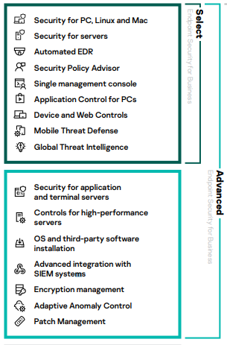

1. Shall we quote as per the BOQ uploaded on the UGM portal or you have previously shared by email an updated BOQ with the suppliers. If yes, kindly share it with us.***No BoQ is shared; we rely on the site visit of the companies and the BoQ shared is the only one.***
2. ArcGIS Desktop Advanced Single use with maintenance (includes ArcGIS Pro)           X    4

ArcGIS Extension Bundle - ArcGIS 3D Analyst + ArcGIS Spatial Analyst        X    4